Measurement Protocol PAX

General Information:

Test date: Nov. 13, 2025 | Date prev. test: Feb 14 2020 | Test number: 1
Tested by: Alex Pollak/Karen | PAX number: PB-005 | Installed at ant.: 2B
Comments: Prototyping, replace new detector assembly in Y-pol
Known problems:

Setup:

Power supply: | OK NOK | Communication: | OK NOK
Supply current +6V: 1.04A |  | ssh obs@antcntl
Supply current -6V: 0.075A |  | ssh ataant@paxtester | pw: q@n@t
Supply current +5V: 0.044A |  | telnet pax | “help”
 |  | CTRL + ] | “close”

RF Test with VNA:

VNA Setup:

Load configuration: Passband_PAX.sta
Freq Start: 1.0 GHz | Freq Stop: 13.0 GHz | Power Level: -20 dBm
Averaging: enabled | Averaging count: 15 | N. Points: 801 (under Sweep)
VNA : Agilent N5230C 10MHz - 20GHz

VNA to PAX connection: | 1m ABC-CA18 Cable + 20dB Attenuator
Input Power Level to PAX:  (Measured) | @1GHz:  -40.2dBm | @4GHz:  -40.7dBm | @8GHz:  -41.2dBm | @12GHz:  -41.4dBm

PAX to VNA connection: | 2m Fibre Cable + Lab Buddy + AOX Amplifier + 1m ABC-CA18 Cable

Measured Passband with Attenuator set to 7dB each (Complete Link):

X
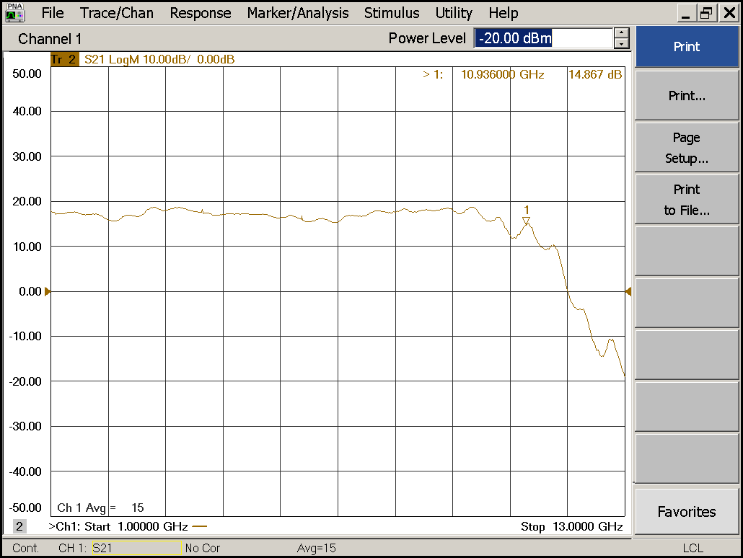

Flatness: | OK NOK | Unwanted Features: | Yes No

Y
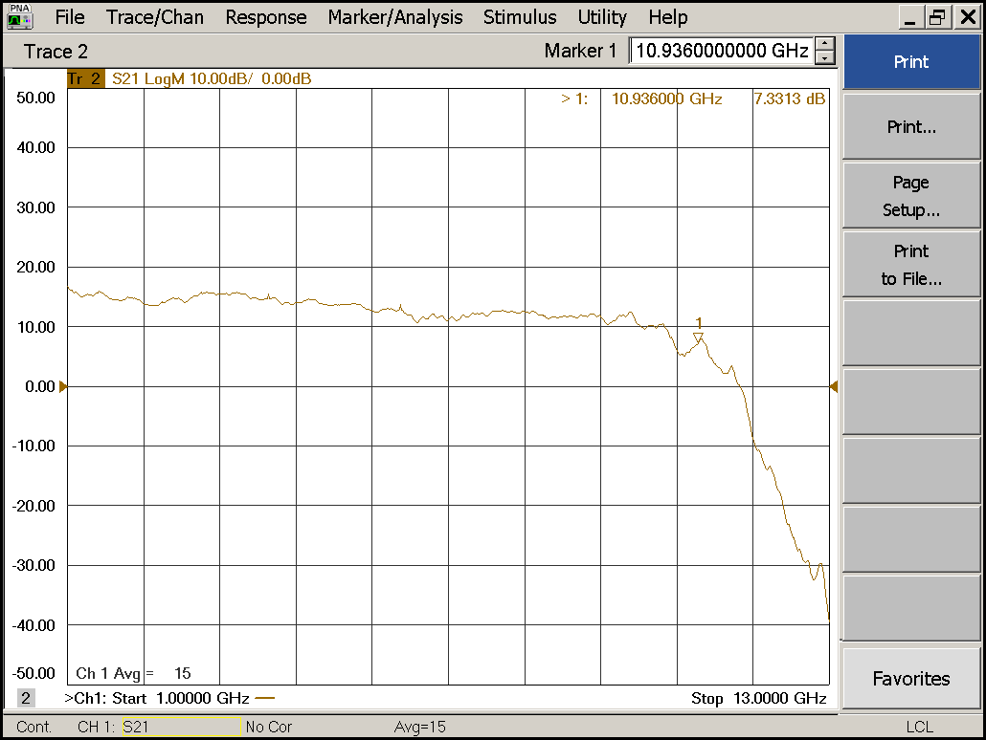

Flatness: | OK NOK | Unwanted Features: | Yes No
Power Sweep (Complete Link):

Load configuration: Power_Sweep_PAX.sta
Power Start: -40dBm | Power Stop: -20dBm | Frequency : 4.0GHz
PAM Attenuator: 0dB |  | N. Points: 801

X
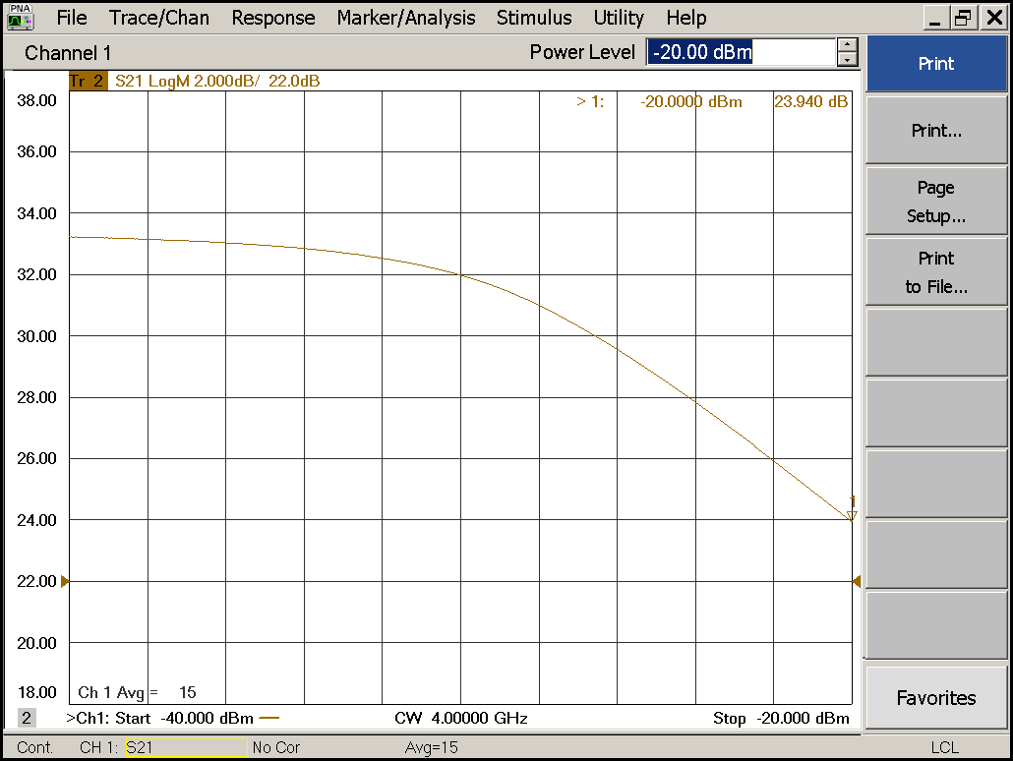

Compression point: | OK NOK | Unwanted Features: | Yes No

Y
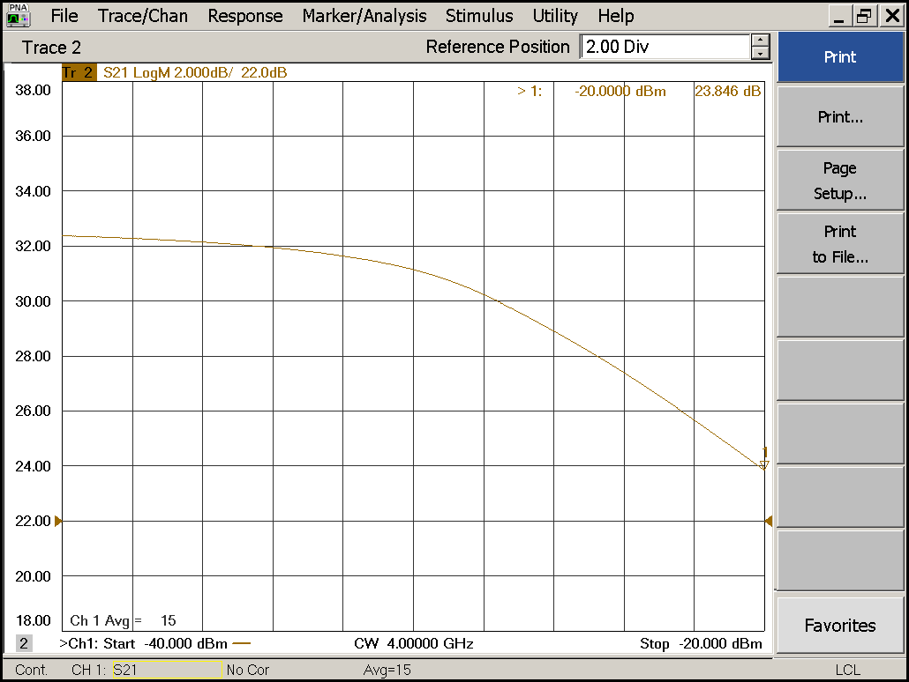
Compression point: | OK NOK | Unwanted Features: | Yes No

Detector Calibration and Attenuator Sweep Pol X:
Use Signal generator instead of VNA now
SMB-100B signal generator
Remove 20dB attenuator
Use 2m ABC-CA18 cable
Connect to diode power sensor

Load configuration: Detector_Calibration_PAX.csa
Freq : 4.0 GHz | Power Level: -38.2dBm
Mode: CW (Continuous Wave) | Power Level at PAX Input (Measured): -40.1dBm

X
CW Input Power [dBm]: | Attenuator Value A [dB]: | Attenuator Value: B [dB]: | Detector  Value: | Power Meter  Value [dBm]:
-40.1 | 0 | 0 | 0.8377 | 12.4
-40.1 | 0 | 3 | 0.8381 | 12.3
-40.1 | 0 | 6 | 0.8399 | 11.6
-40.1 | 0 | 9 | 0.8364 | 9.1
-40.1 | 0 | 12 | 0.8383 | 6.7
-40.1 | 0 | 15 | 0.8396 | 4.4
-40.1 | 0 | 18 | 0.6669 | 0.3
-40.1 | 0 | 21 | 0.3908 | -2.1
-40.1 | 3 | 21 | 0.1905 | -5.4
-40.1 | 6 | 21 | 0.0932 | -8.3
-40.1 | 9 | 21 | 0.0531 | -11.4
-40.1 | 12 | 21 | 0.0268 | -14.5
-40.1 | 15 | 21 | 0.0125 | -17.5
-40.1 | 18 | 21 | 0.0074 | -20.5
-40.1 | 21 | 21 | 0.0042 | -23.4
-40.1 | 24 | 21 | 0.0026 | -26.1
-40.1 | 27 | 21 | 0.0017 | -29.2
-40.1 | 30 | 21 | 0.0012 | -32.4
-40.1 | 30 | 24 | 0.0011 | -35.1
-40.1 | 30 | 27 | 0.0010 | -37.5
-40.1 | 30 | 30 | 0.0009 | -40.0

Use Noise Source: Atlantic AS6333
Freq : 1.0 - 12.0GHz | Power Level: -41.8dBm
DC Supply: 28V

X
Input Power [dBm]: | Attenuator Value A [dB]: | Attenuator Value: B [dB]: | Detector  Value: | Power Meter  Value [dBm]:
-41.8 | 0 | 0 | 0.8325 | 9.7
-41.8 | 0 | 3 | 0.8349 | 9.1
-41.8 | 0 | 6 | 0.8364 | 7.6
-41.8 | 0 | 9 | 0.8379 | 5.9
-41.8 | 0 | 12 | 0.8374 | 3.3
-41.8 | 0 | 15 | 0.8165 | 1.2
-41.8 | 0 | 18 | 0.4429 | -1.9
-41.8 | 0 | 21 | 0.2533 | -4.5
-41.8 | 3 | 21 | 0.1079 | -8.5
-41.8 | 6 | 21 | 0.0574 | -11.1
-41.8 | 9 | 21 | 0.0278 | -13.9
-41.8 | 12 | 21 | 0.0160 | -16.5
-41.8 | 15 | 21 | 0.0090 | -19.3
-41.8 | 18 | 21 | 0.0042 | -22.6
-41.8 | 21 | 21 | 0.0024 | -26.1
-41.8 | 24 | 21 | 0.0017 | -29.2
-41.8 | 27 | 21 | 0.0013 | -31.7
-41.8 | 30 | 21 | 0.0011 | -35.8
-41.8 | 30 | 24 | 0.0009 | -37.2
-41.8 | 30 | 27 | 0.0009 | -39.3
-41.8 | 30 | 30 | 0.0009 | -41.3

Detector Calibration and Attenuator Sweep Pol Y:

Load configuration: Detector_Calibration_PAX.csa
Freq : 4.0 GHz | Power Level: -20dBm | Sweep Time: -20sec
Sweep Mode: CW | Power Level at PAX Input (Measured): -40.1dBm

Y
CW Input Power [dBm]: | Attenuator Value A [dB]: | Attenuator Value: B [dB]: | Detector  Value: | Power Meter  Value [dBm]:
-40.1 | 0 | 0 | 0.1899 | 10.8
-40.1 | 0 | 3 | 0.1862 | 10.5
-40.1 | 0 | 6 | 0.1694 | 9.5
-40.1 | 0 | 9 | 0.1411 | 7.6
-40.1 | 0 | 12 | 0.1058 | 4.8
-40.1 | 0 | 15 | 0.0802 | 2.1
-40.1 | 0 | 18 | 0.0561 | -1.5
-40.1 | 0 | 21 | 0.0432 | -4.5
-40.1 | 3 | 21 | 0.0226 | -7.8
-40.1 | 6 | 21 | 0.0163 | -12.9
-40.1 | 9 | 21 | 0.0119 | -15.1
-40.1 | 12 | 21 | 0.0097 | -18.3
-40.1 | 15 | 21 | 0.0072 | -21.7
-40.1 | 18 | 21 | 0.0054 | -24.6
-40.1 | 21 | 21 | 0.0044 | -27.6
-40.1 | 24 | 21 | 0.0038 | -30.6
-40.1 | 27 | 21 | 0.0036 | -32.8
-40.1 | 30 | 21 | 0.0033 | -35.4
-40.1 | 30 | 24 | 0.0031 | -37.6
-40.1 | 30 | 27 | 0.0030 | -39.5
-40.1 | 30 | 30 | 0.0029 | -42.0

Use Noise Source: Atlantic AS6333
Freq : 1.0 - 12.0GHz | Power Level: -41.8dBm
DC Supply: 28V

Y
Input Power [dBm]: | Attenuator Value A [dB]: | Attenuator Value: B [dB]: | Detector  Value: | Power Meter  Value [dBm]:
-41.8 | 0 | 0 | 0.1735 | 8.4
-41.8 | 0 | 3 | 0.1437 | 7.3
-41.8 | 0 | 6 | 0.1205 | 4.6
-41.8 | 0 | 9 | 0.0947 | 2.6
-41.8 | 0 | 12 | 0.0631 | -1.3
-41.8 | 0 | 15 | 0.0497 | -3.6
-41.8 | 0 | 18 | 0.0338 | -5.5
-41.8 | 0 | 21 | 0.0259 | -8.5
-41.8 | 3 | 21 | 0.0187 | -11.2
-41.8 | 6 | 21 | 0.0138 | -14.2
-41.8 | 9 | 21 | 0.0098 | -16.9
-41.8 | 12 | 21 | 0.0073 | -20.0
-41.8 | 15 | 21 | 0.0065 | -22.6
-41.8 | 18 | 21 | 0.0045 | -25.8
-41.8 | 21 | 21 | 0.0039 | -28.9
-41.8 | 24 | 21 | 0.0034 | -31.8
-41.8 | 27 | 21 | 0.0031 | -34.6
-41.8 | 30 | 21 | 0.0029 | -37.8
-41.8 | 30 | 24 | 0.0029 | -40.2
-41.8 | 30 | 27 | 0.0028 | -42.3
-41.8 | 30 | 30 | 0.0029 | -44.4

Inspection:

Visual:
Fibre Connectors Clean | Comments: | OK NOK
Fibre Connector Mechanical | Comments: | OK NOK
RF Cable | Comments: | OK NOK
RF Connectors Clean | Comments: | OK NOK

Functions:
Read Temperature Value | Comments: 31.7 | OK NOK
LNA Settings | Comments: | OK NOK
Temperature Stabilisation | Comments: | OK NOK
 |  | OK NOK

